Ergonomic Task Analysis

Department:_______________________ Production Rate Per Employee:_________________ Team Member:_________________
Name:___________________
Job:______________________________ Cycle Time:____________________ Date:___________________

Tasks (job steps) | Hands & Wrist |  |  |  | Grip |  |  |  | Elbow & Forearms |  |  |  | Shoulders |  |  |  | Neck |  | Back |  | Legs |  |  |  | Total Risk  Factors
 | Left |  | Right |  | Left |  | Right |  | Left |  | Right |  | Left |  | Right |  |  |  |  |  | Left |  | Right |  | per cycle |  | per shift
Total Risk Factors Per Cycle
Total Risk Factors Per Shift
Notes:
Ergonomic Task Analysis Awkward Posture Identifier

Hands & Wrist | Grip | Elbows & Forearm | Shoulder | Neck | Back | Legs
Flexion-(F)  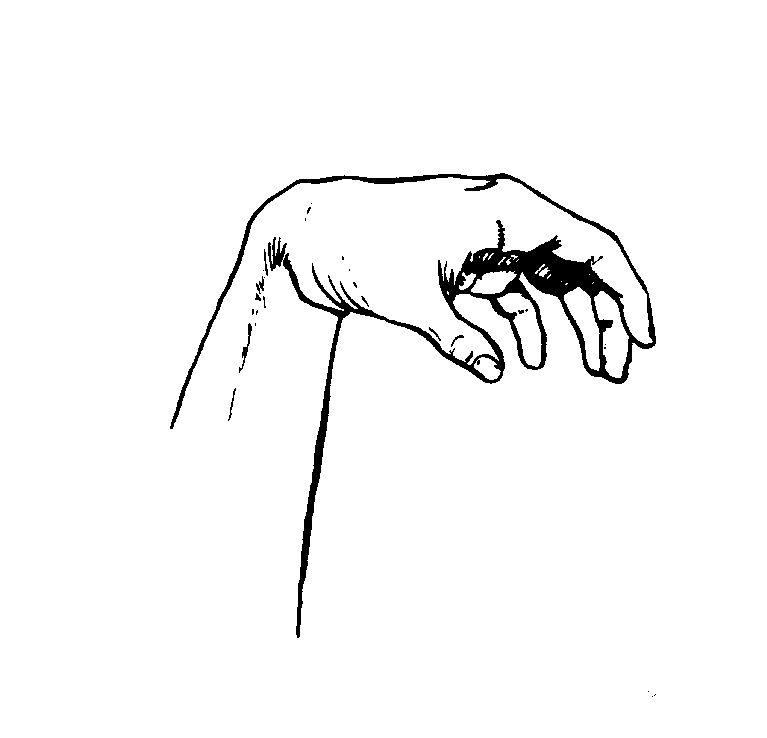 | Lateral Pinch- (P)  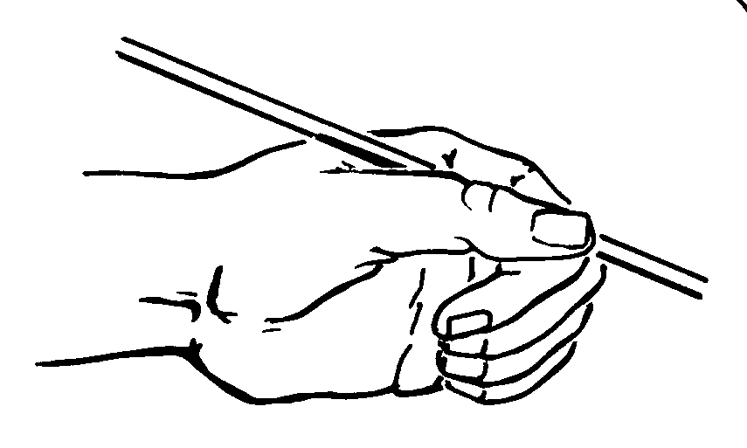 | Flexion-(F)  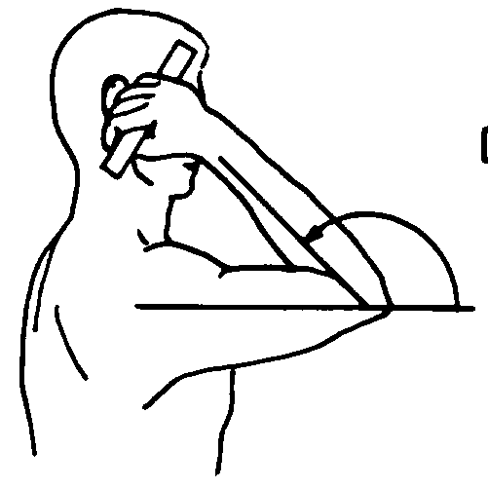 | Adduction-(AD)  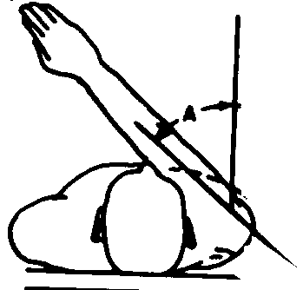 | Flexion-(F)  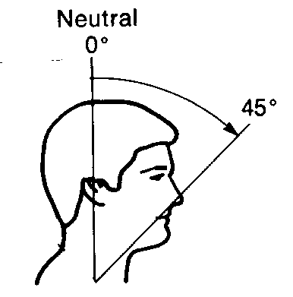 | Flexion-(F)  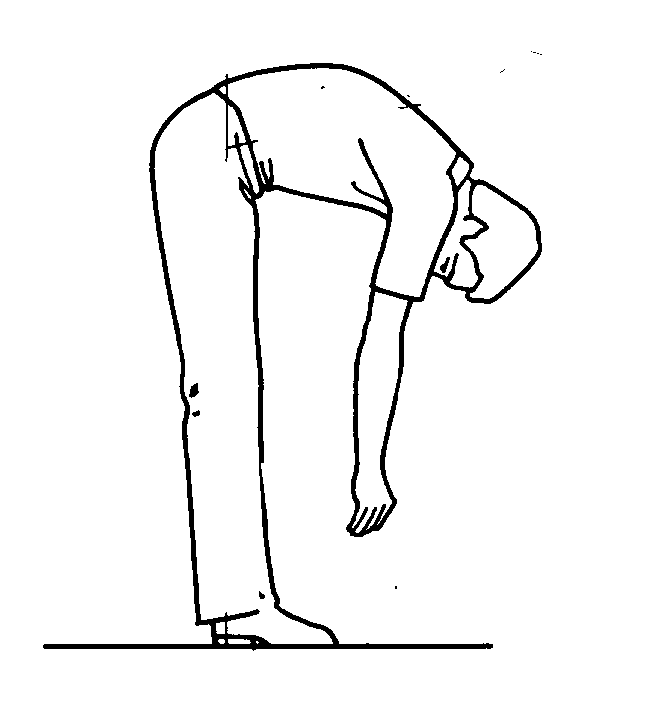 | Static Exertion-(SE)   Prolonged standing without movement   Walking less than 2-4 min. every 15 minutes
Extension-(E)  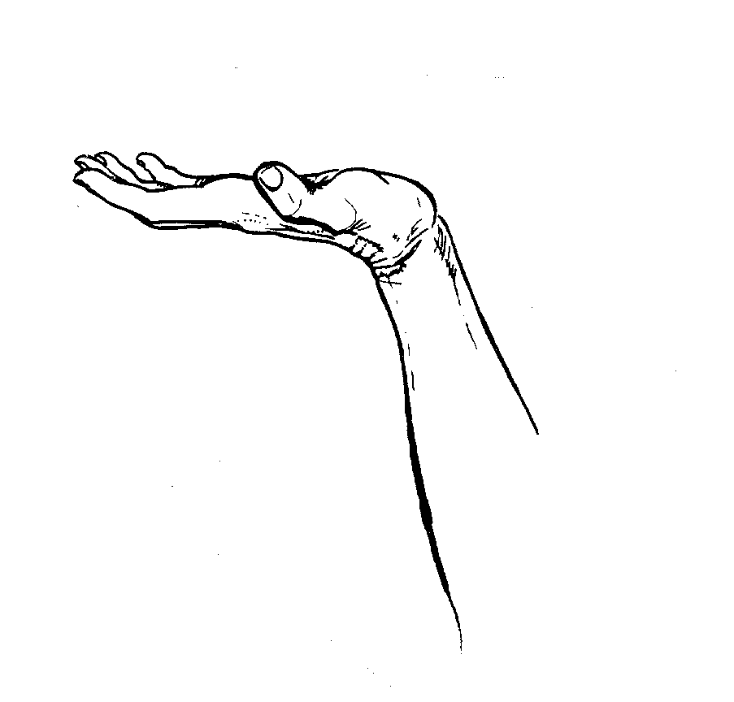 | Precision Pinch-(P)  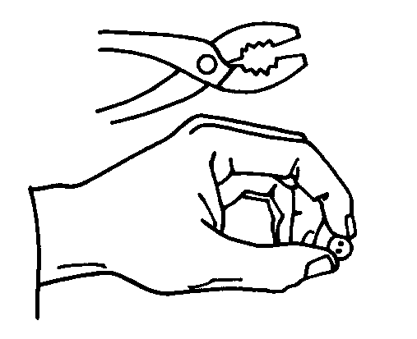 | Rotation-(R)  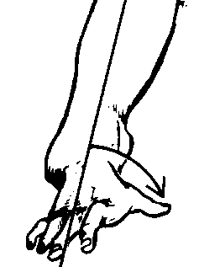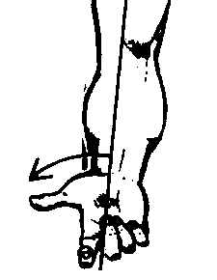 | Abduction-(AB)  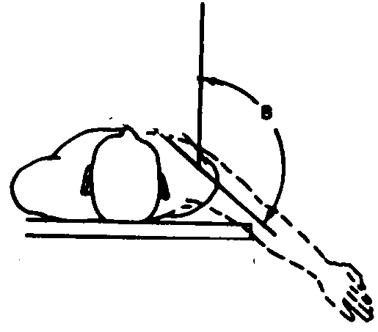 | Extension-(E)  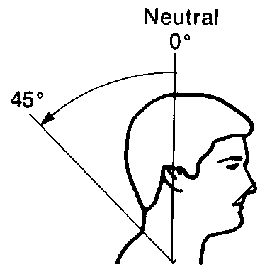 | Twist-(CW)  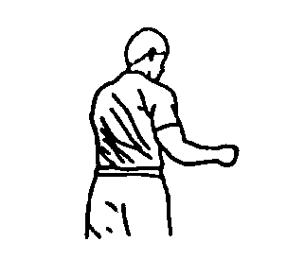 | Foot pedal/static-(SE)  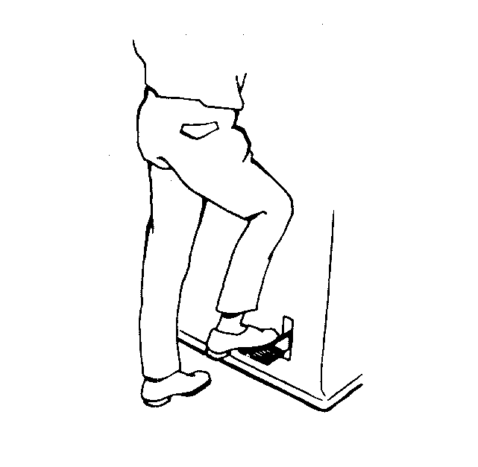
Radial Deviation-(RD)  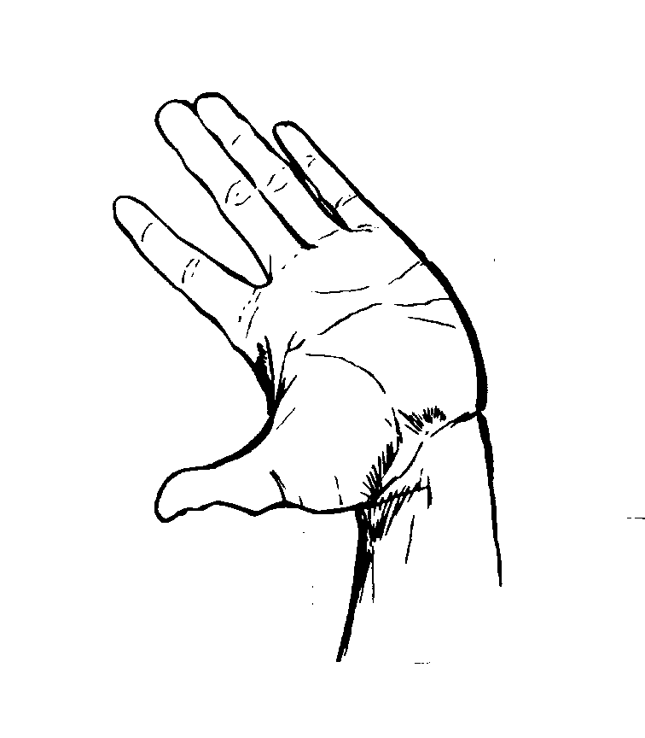 | Palm Pinch- (P)  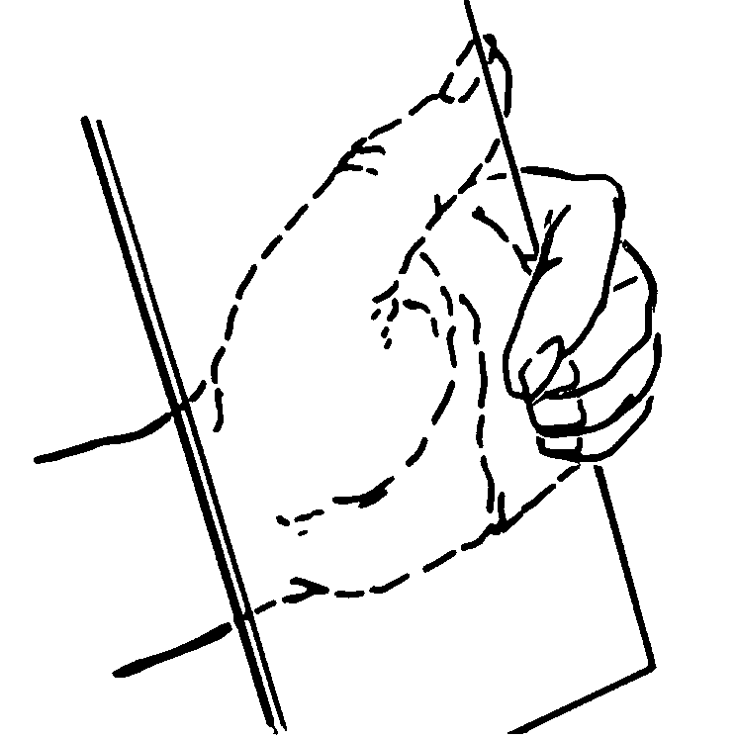 | Reach-(R)  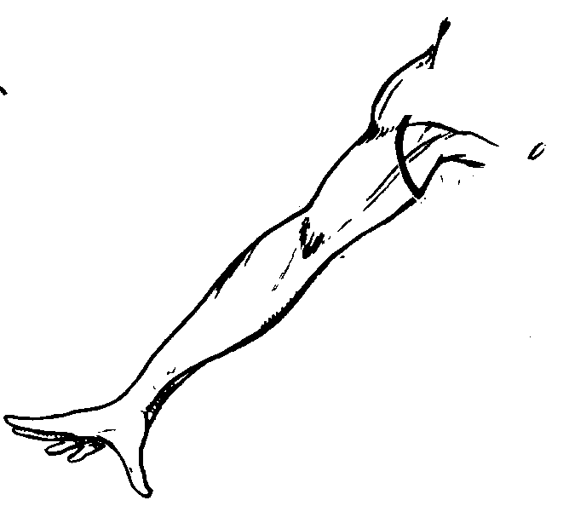 | Flexion (F)  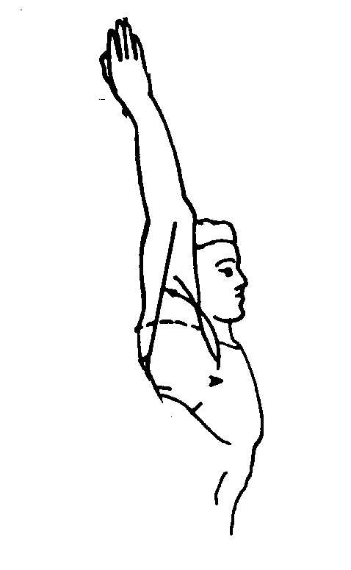 | Rotation-(R)  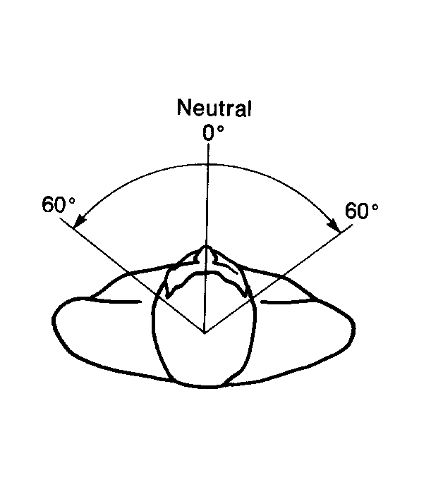 | Twist-(CC)  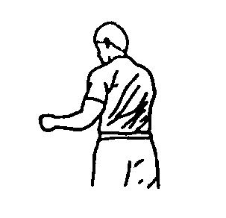
Ulnar Deviation-(UD) |  | Static Exertion-(SE)   High-If 9 lb. object is held for 10 sec. or more   Moderate-If 4 lb. Object is held for 1 min. or more | Extension-(E)

